Name : Om Maroti Munjale

Roll no. : 24

Section : B

Subject : PE-I (DSS)

Date : 05-07-2024

**Experiment 1: Study of anaconda IDE and it’s installation.**

**Study of Anaconda IDE and Its Installation**

Anaconda is a powerful, free, and open-source distribution of Python and R programming languages, widely used in data science, machine learning, artificial intelligence, and scientific computing. It simplifies package management and deployment, making it a popular tool for both beginners and experts. Here's a breakdown of Anaconda IDE and how to install it.

**1. What is Anaconda?**

Anaconda is an Integrated Development Environment (IDE) that provides a comprehensive platform to work on data science projects. It comes with over 1,500 popular data science packages like Pandas, NumPy, Matplotlib, SciPy, and others. These tools help in data analysis, visualization, and processing.

**Key Features of Anaconda:**

Conda: A package manager that helps manage libraries and dependencies.

Jupyter Notebooks: Interactive notebooks for code, visualization, and documentation.

Spyder IDE: A powerful IDE for scientific programming.

Python and R Support: Pre-configured environments for both Python and R.

Cross-Platform: Works on Windows, macOS, and Linux.

**Why Use Anaconda?**

Easy Package Management: Managing libraries and dependencies is often hard, but Anaconda simplifies it with Conda, which automatically handles versions and dependencies.

Pre-installed Libraries: Comes with essential libraries for machine learning and data analysis, reducing the need to install them separately.

Jupyter Notebooks: Allows users to write and execute code interactively, making data exploration and visualization easier.

**2. Installing Anaconda IDE on Windows**

Here is a step-by-step guide to installing Anaconda on Windows.

**Step 1: Download Anaconda**

Open a web browser and go to Anaconda's official download page.

Choose the installer for your operating system (Windows).

Select the Python 3.x version, as Python 2 is outdated.

Click on the download button.

**Step 2: Launch the Installer**

Locate the downloaded installer (usually in the 'Downloads' folder).

Double-click on the installer to launch the setup wizard.

**Step 3: Follow the Installation Wizard**

Welcome Screen: Click on the "Next" button to proceed.

License Agreement: Read and agree to the license terms by clicking on "I Agree."

Select Installation Type: Choose "Just Me" unless you want to install Anaconda for all users.

Select Installation Location: By default, it installs in the user directory (C:\Users\YourName\Anaconda3). You can choose a different folder if needed.

Advanced Installation Options:

Add Anaconda to my PATH environment variable: Do not check this option (it’s recommended to use Conda without adding it to PATH).

Register Anaconda as my default Python 3.x: You can check this if you want Anaconda to manage your Python version.

Click "Install" to start the installation process.

**Step 4: Complete Installation**

After installation, click on the "Finish" button. You now have Anaconda installed.

**Step 5: Verify Installation**

Open the Anaconda Navigator from the Start menu.

The navigator provides an easy-to-use graphical interface where you can launch tools like Jupyter Notebooks, Spyder IDE, or create new environments.

**Setting Up the Environment**

Anaconda allows you to create separate environments for different projects, ensuring that dependencies do not conflict.

**Creating a New Environment:**

1.Open Anaconda Navigator.

2.Click on the "Environments" tab on the left-hand side.

3.Click on "Create" to create a new environment.

4.Choose a name for the environment and select the version of Python or R you want to use.

Once the environment is created, you can install specific packages in this environment using conda install <package-name>.

5. Key Tools Available in Anaconda

Jupyter Notebooks: Interactive documents where you can combine code, equations, and visualizations. It's great for data analysis and exploration.

6.To launch Jupyter, open Anaconda Navigator and click "Launch" under the Jupyter Notebook option.

7.Spyder IDE: A scientific IDE that provides an integrated environment for Python development. It has features like debugging, variable explorer, and integration with IPython.

8.You can launch Spyder from the Anaconda Navigator or by typing spyder in the Anaconda Prompt.

9. Managing Packages in Anaconda

Managing packages is easy with Conda, the package manager for Anaconda.

**Installing Packages:**

To install a package, open the Anaconda Prompt or Terminal (on macOS/Linux) and type the following command:

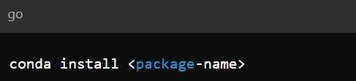

For example, to install the matplotlib package, use:

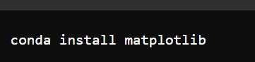

Updating Packages:

You can update any package using:



Removing Packages:

To remove a package, use:

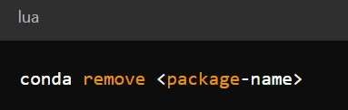

6. Keeping Anaconda Updated

It is important to keep your Anaconda distribution and packages updated.

To update Anaconda, type this command in the Anaconda Prompt:

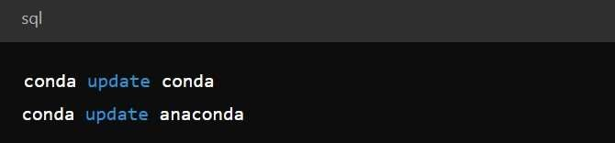

Anaconda will check for available updates and apply them.

**Conclusion:**

Anaconda is an essential tool for anyone interested in data science, machine learning, and scientific computing. With its easy-to-use interface, package management system, and pre-installed libraries, it saves time and effort for developers and researchers alike. Installation is straightforward, and the inclusion of tools like Jupyter Notebooks and Spyder IDE makes it an all-in-one solution for Python and R development.